InnoLead Members’ Meeting
Metrics & Communication Best Practices
October 28, 2022

See below for some of the links and charts we shared during the meeting, as well as some notes on the top 10 take-aways.

Special guests included Charu Jain, SVP of Merchandising and Innovation at Alaska Airlines, and Michelle Cohen, Senior Director of Innovation and Acceleration at CME Group.

=-=-=-=-=-=-=-=

10 Key Takeaways:
- Net Promoter Score can be important, but it is also sometimes difficult to use and to integrate across an organization.
- Varying definitions, not just of what gets measured, but also of innovation itself, make it hard to measure intangible things.
- A broad definition of innovation and innovation metrics allows for better flexibility.
- Innovators indicated that their organizations and teams have a lot of questions around how to best measure innovation culture in an organization.
- Cost reduction and revenue creation are two metrics that hold a lot of importance and pull in many large companies.
- But, innovators shared that sometimes, when standing up an innovation function for the first time, it can be more useful to focus on activity-focused metrics, like the number of ideas generated and acted upon.
- When long-term projects won’t immediately impact financial metrics, keeping momentum is extremely important.
- However, some innovators struggle to keep momentum on long-term innovation projects when they also receive an influx of immediate needs or urgent requests; they don’t have the resources to handle both simultaneously.
- One of the keys to longevity for an innovation team is support from multiple stakeholder groups. Buy-in from C-Suite leadership matters, but so does creating a grassroots feel around innovation — if many groups of employees (not just innovators) are directly invested in innovation, it has a better chance of surviving in an organization.
- Implementation can be difficult once innovators have brought a project to fruition, often because they have to rely on another team to make sure it happens. Our members told us that not only is implementation an issue, but it’s not one that there are strong metrics in place to measure.

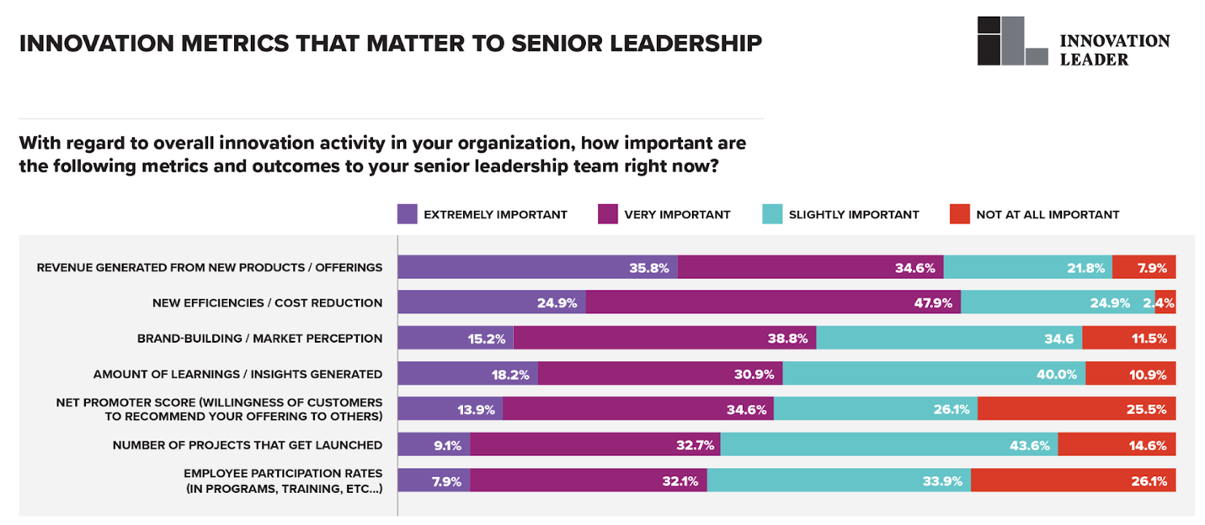

Source: https://www.innovationleader.com/research-reports/delivering-value-through-emerging-tech-innovation/

Create a baseline metric - similar to NPS score:

https://www.innovationleader.com/resource/scorecard-create-a-baseline-set-of-innovation-metrics-for-your-org/

2021 report on metrics:

https://www.innovationleader.com/research-reports/developing-innovation-metrics-reports-that-really-matter/

Fidelity SVP: The only success metrics that really matter are financial metrics:

https://www.innovationleader.com/topics/articles-and-content-by-topic/politics-and-business-unit-engagement/fidelity-labs-svp-the-only-success-metrics-that-really-matter-are-financial-metrics/

Survey questions on innovation culture:
https://www.innovationleader.com/resource/survey-questions-on-innovation-culture/

