Survey Questions: Is your company’s culture supportive of innovation?
We’ve collected these questions from innovation and R&D executives. We definitely don’t suggest using all of them in one survey, since shorter surveys will yield more (and more thoughtful) responses. But the executives with whom we’ve spoken suggest that a quarterly or annual cultural “temperature taking” of employees and managers is essential to understanding whether your work is having a broad, positive impact on the overall culture; whether you’re in neutral; or whether things are getting worse along some dimensions. Choose the questions that are most relevant to things you’re trying to impact.
1. I get involved in the company’s innovation efforts. | 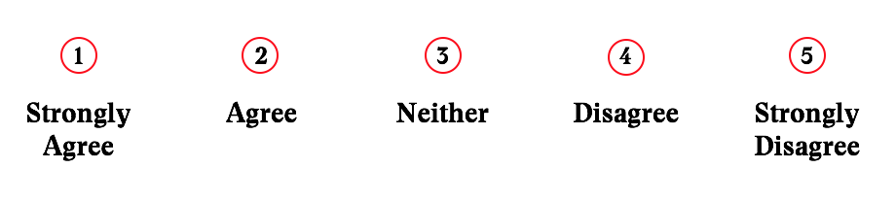
2. The company provides me with the resources (time, training, funding, etc.) I need to bring my ideas to life.
3. The company has incentives that encourage me to take risks.
4. In my performance review, I get credit for new ideas and working to make them happen.
5. I understand the company’s priorities related to innovation and the kinds of new ideas we’re looking for.
6. I feel that being innovative and developing new ways to serve our customers or reduce costs is an important aspect of my job.
7. Our innovation activities are moving the company in the right direction as our market evolves.
8. I am proud of our company’s culture of innovation and the way we are perceived in the market.

9. Good ideas sometimes get abandoned, forgotten, or under-resourced.
10. People outside of the company — such as customers, suppliers, or people in my professional network — regard us as an innovative company.
11. Our company recognizes and rewards people who bring new ideas to life.
12. We are encouraged to conduct small-scale experiments to get an early read on an idea’s merit.

13. I don't need to ask for permission to pursue ideas that may result in significant change.
14. Our senior leaders are patient in nurturing a new idea or project long enough for it to demonstrate value.

15. I'm encouraged and empowered to initiate
change, no matter what
level of seniority I am.
16. My company has a good understanding of the trends that are shaping our markets and impacting our company.

17. The company is open to good ideas from outside, whether our customers, business partners, inventors, or entrepreneurs.

18. How could our company could become more supportive of people with new ideas?

19. What barriers or roadblocks exist that
impede progress in developing ideas?

20. What would be the most effective thing we could do to “move the needle” on building a culture of innovation in our company? | □ More frequent communications on how innovation is taking shape in our company  □ More time to develop new ideas and concepts  □ More funding to develop new prototypes  □ More recognition for those who try out new things  □ Online community or regular meetings for innovators  □ Other (please specify):

For more on Innovation Leader’s resources, visit InnovationLeader.com.

